Toronto Location Substitution for Television Dramas set in Chicago

John Morris, Team Condor, Location Dynamics Inc.

September 3, 2021

- Introduction

  - Background
William F. Fox productions has 3 television programs for a major television network, Chicago Crime, Chicago Hospital and Chicago Emergency Response. These are collectively known as “The Chicago Dramas”. These shows are set and actually filmed in the City of Chicago, America’s third largest city, located in the central part of the country on the shores of Lake Michigan. While low compared to cities such as New York or San Francisco, they are high compared to other cities such as Atlanta or Toronto. A number of television and movie productions set in Chicago were actually filmed, all or in part in Toronto or Atlanta or New Orleans. Local production costs are a factor as well as state and national production subsidies.
Appendix 1 lists an email chain that details that the production company faces budget cuts from the television network and will have to move production to Toronto to save money and gain additional tax credits from the Canadian and Ontario governments.

  - Problem
Authenticity is one of the hallmarks of “The Chicago Dramas”. William F. Fox uses the actual locations mentioned in the scripts and often includes locally recognizable landmarks in scenes.
Moving to Toronto will pose a problem for WF Fox because the team has never worked on productions in Chicago. In a short period of time they will have to determine substitute locations for the Chicago Scenes planned in the current season. To expedite the process, it was decided to use Architectural, Census and Foursquare data to attempt to more easily match Chicago locations with appropriate substitute locations in Toronto. Team Able is the data team that is comparing the types of buildings and architectural styles in curently planned shooting locatons with various Toronto neighborhoods. Team Beagle is reviewing Chicago and Toronto census data to match up neighborhoods. It would not do to film an episode set in a working class African-American neighborhood in an upscale all Caucasian neighborhood. Team Condor is focused on using Foursquare data to compare neighborhoods based upon the similarity of Ameniites in the neighborhood- types of stores, restaurants and services. An executive team will consolidate this data to provide guidance for the WF Fox team to narrow the focus of the location scouts that wil visit Toronto to determine the actual filming locations. This report is limited to the tasks before Team Condor.

  - Interest
WF Fox would like to have a narrowed list of neighborhoods to reduce the time and expense for location scouts to deterimine the substitute locations for the current seasons episodes. The most critica neighborhoods where 90% of the episodes are set are in the following community areas in Chicago: Near North Side, Englewood, West Town, Humbolt Park, Lincoln Park and Archer Heights. Given years of shooting on Chicago locations, perfect substitution is not necessary, however the closer the match, the better.

- Data Acquisition and Cleaning.

  - Data Sources
Foursquare has amenities data available for both Toronto and Chicago. It will require geocoding to identify this data to be used for analysis.
Chicago has 77 standard Community Areas and Toronto proper has 34 postal codes. These will be uses to identify the areas for comparison for this analysis.
The Chicago Community Areas Names, population and area data is available from the City of Chicago Data portal: https://data.cityofchicago.org/Facilities-Geographic-Boundaries/Boundaries-Community-Areas-current-/cauq-8yn6. However, this data does not have the geocoding as single point. This was obtained from Wikipedia and manually transcribed onto the datafile.
The Toronto Postal Codes data was also obtained from Wikipedia.
This data was combined into a single file and Amenities data was downloaded from Foursquare.

  - Data Cleaning.

The Chicago and Toronto Data were loaded into Pandas Dataframes. The key location identifier for Chicago was Community Area, while for Toronto it was Postal Code. These were combined into a single master list with these as Area_ID. This allows the matching of Foursquare data into a single dataframe to facilitate clustering both Chicago and Toronto Neighborhoods.
The Toronto Data set was uploaded first. The dataset was restricted to Postal Codes within the city of Toronto proper. The Chicago Data set by design is limited to the city proper.

The dataset for Toronto consisted of 103postal codes. This was reduced to 39 postal codes by restricting the set to Toronto proper.
The Head for this dataset is:
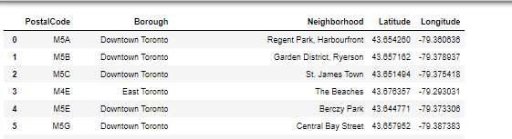
Map the Postal Codes in Toronto:
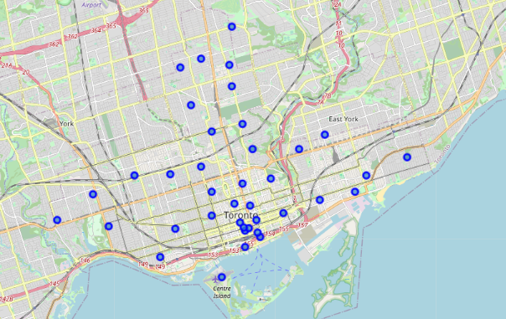
The dataset for Chicago consisted of a csv file with 77 records- one for each community area;
The Head for this dataset is:
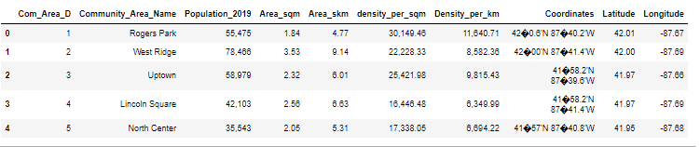

Map the Community Areas of Chicago:

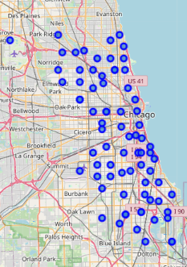

Next Combine the two files into a single dataframe. Combine Community_Area_Name and PostalCode into a single field Area_ID.

The resulting file will look like this:
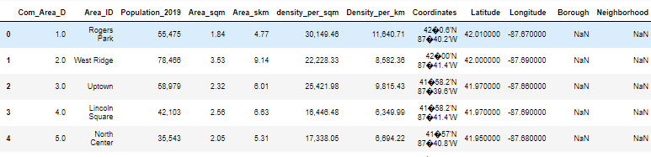

We do not need all these data elements so we reduce to a smaller set:
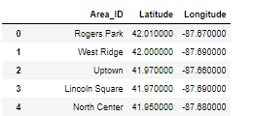
  - Feature Selection

The geolocation of the Area_ID will be used to pull venue information from a 500MM radius.

Next is to link up to Foursquare Dtata:

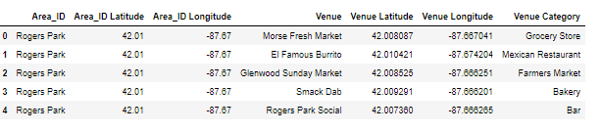
Group this data by Area_ID, one hot encode and then normalize resulting in:
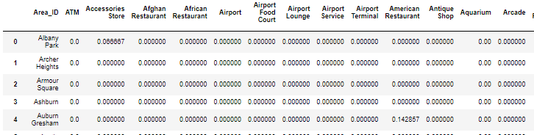
The shape is 115,305.

- Methodology
  - Exploratory Data Analysis

The data set with Foursquare data is for 115 Areas (77 Chicago and 38 Toronto Postal Codes) and has 304 Unique categories of data. Due to time constraints for the project, the team elected not to consolidate these categories prior to clustering.

To aid in refining selection of substitute areas, we looked at top venues in each area.
The output looked like this:

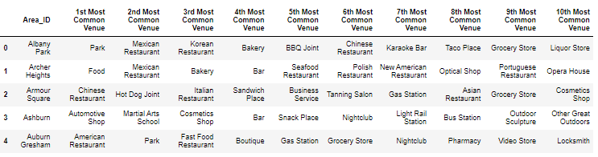
4.0 Clustering

4.1 Clustering method selection
This project calls for the use of an unsupervised clustering method. K-means was selected as a method to cluster the Chicago and Toronto Neighborhoods. K-means is applicable because the data will be numerical data on the number of venues in each category.

4.2 K-Means Clustering
K-means was run to generate 12 clusters. The clustering results were reviewed for the 5 most critical community areas. Archer Heights, West Town and Humbolt Park areas were clustered with only 3 other Toronto Postal Codes. However, Endglewood, Lincoln Park and Near North Side were all clusted in a cluster with 30 of the 38 Toronto Postal Codes. To better refine this cluster, K-means was run again for all the Areas within that cluster to generate an additional 6 clusters. The results of this placed the Lincoln Park and Near North Was clustered in a cluster with the M4K Postal Code in Toronto. The Englewood Community Area was isolated into its own cluster. The Englewood Community is an economically distressed, high violent crime neighborhood that may have no close analog in Toronto.

4.3 Clustering Results

The full listing is contained in Appendix 2.

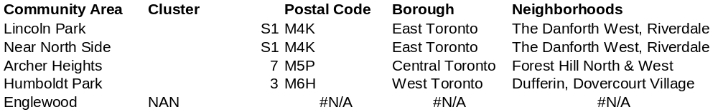
For the 6 critical Community Areas, the results are listed below:

Englewood did not come up with a cluster match with any Toronto Neighborhoods. Englewood is a nearly 100% African-American, very low-income area that is probably unlike any in Toronto.

5, Conclusions
The neighborhood character analyis using Foursquare data, when combined with the streetscape (architectural) and demographic analyses of the other teams will allow the firm to greatly narrow the areas of the city of Toronto for location scouting. It is recommended that the firm consider not relocating scenes planned for Englewood Area at this time.
Location Scounts should visit and review areas such as The Danforth West and Riverdale, Forest Hill North, Forest Hill West, Duffering and Dovercourt Village for the coming episodes on the shooting schedule.

6. Further Directions
This analysis is only limited to comparison of neighborhood amenities. It needs to be combined with the Streetscape and Demographic Analyses to allow the productions teams to be able to more easily replicate an authentic “Chicago” feel to the production.
Further analysis of this data should involve expansion of the search areas both within Chicago and Toronto. The Chicago geography could be moved from Community Area to postal Zip codes and both Toronto and Chicago areas should be expanded to cover the entire metro area.s of each.

The Foursquare Data should be condensed to reduce the number of Unique venue categories. For example Gym should be combined with Gym/Fitness Center or the various restaurant types should be condensed into broader categories: Asian (vs Japanese/Korea, etc,) , Latin (vs. Mexican/Brazilian, etc.) European, and so forth. This should increase the chances for more m eaninful clustering.
Appendix 1 Project Background
This is a project to compare community areas in the City of Chicago with Neighborhoods in Toronto to determine suitable substitue filming locations for a set of TV productions. The email chain below gives the background of the project and the approach. This assignment will focus only on the work of Team Condor.

COMPANY CONFIDENTIAL

TO; Bill Fox, Executive Producer, William F. Fox Productions
FROM: Ted Armstrong, Network Production Executive, American National Broadcasting Network
SUBJECT: 2022 Product Budget Changes

Bill,
I have some harsh news to tell you. Despite the ratings success of your Chicago Dramas, Chicago Crime, Chicago Hospital and Chicago Emergency Response; the network executives have directed me to cut your overall production budget for next season by 20%.
I realize that you just negotiated new salaries for the talent and you will have limited areas to make cuts. I must assure you that other programs are facing the same types of cuts.
I would suggest that you follow the lead of the other programs and consider moving production to less expensive locations. Several of the Los Angeles based productions are shifting production to Vancouver. Some New York productions are scheduling shooting in Toronto and Chicago. I would strongly suggest you consider Toronto as many other productions have in the past.

Regardless, the budget changes are final and I will leave it up to you and your team to decide how to work within these limits while still maintaining the high production quality we have come to expect of the Chicago Action franchise.

Ted

TO: Laura Lee, Production Services Director
FROM: Bill Fox
RE: 2022 Production Budget Changes

Laura,

This confirms it, the rumors are true, NY is slashing budgets. I did my own check and the only area we have any flex is in the location shooting budget. Pretty much all else is locked in. With the scripts already in the can, we are going to have to scramble to find locations in Toronto that will have the similar look and feel of our planned Chicago locations. This is probably going to be a long term issue so we will need to be prepared to have substitutes of any Chicago area.
Lets engage that Data Science team that made a pitch to us about using Foursquare, Emporis and Census data to help us in our planning for location scouting. This seems right up their alley.

I don’t need to remind you this is very hush-hush so all discretion is required. This is you and I and the data team only for now.

Bill

TO: Bill Fox,
FROM: Laura Lee, Production Services Director
RE:RE: 2022 Production Budget Changes

Bill,

I expected this. My friends on LA Action Rescue and NCIS:Santa Monic warned me this was about to drop. I will contact the data team. My proposal for the project is to look at three areas:
- Archtechture and Streetscape. This team should review Emporis data on the buildings in the various neighborhoods to match the architechural makeup of the neighborhoods in Toronto and Chicago. We need to have a visually similar appearance of the streetscape.
- Demographics. This team should review the demographic data comparing neighborhoods, we don’t want to try to film a scene set in nearly all African-American Englewood in a Toronto Neighborhood that is upscale Asian.
- Character and Amenities. This is different than we have done before (just 1&2), we need to factor in the character of the neighborhood by leveraging data on the number and types of various amenities such as restaurants, entertainment venues, shopping venues.

We can then have them combine this analysis to give us the best substitue neighborhoods in Toronto for our current (and future) planned Chicago shooting locations.

I will have them prioritize the following Chicago Community Areas:
Near North Side,
Englewood,
Wicker Park,
Humbolt Park
Lincoln Park
Archer Heights

If we can’t find good analogs for these areas we will have extreme difficulty with our 2022 season.

I will contact the team and get this rolling.

Laura

TO: Doug West, CEO, Location Dynamics
FROM: Laura Lee, Production Services Director, William F. Fox Productions
SUBJECT: Location Analysis Project

Doug,

Your team’s presentation last month was very impressive. I think we have a project that is right up your team’s alley. Since you signed our NDA (Non-Disclosure Agreement), I will go right ahead lay out what we want. We need you to conduct an analysis to compare Chicago vs. Toronto looking at three major areas:

- Archtechture and Streetscape. Use Emporis data on the buildings in the various neighborhoods to match the architechural makeup of the neighborhoods in Toronto and Chicago.
- Demographics. This team should review the demographic data comparing neighborhoods, We are looking to compare on race/ethnicity, income, crime, employment, household composition, etc.
- Character and Amenities. We need to factor in the character of the neighborhood by leveraging data on the number and types of various amenities such as restaurants, entertainment venues, shopping venues.
- Combine these three analyses to give us the Toronto neighborhoods that are most comparable to the Chicago Community Areas. We are most concerned with these particular areas:
Near North Side,
Englewood,
Wicker Park,
Humbolt Park
Lincoln Park
Archer Heights

This is a highly confidential project and you sole point of contact here at WFF will be myself.

Please let me know if you can tackle this project and when you can complete on an expedited basis.

Best regards,

Laura

TO: Laura Lee, Production Services Director, William F. Fox Productions
FROM: Doug West, CEO, Location Dynamics
RE: Location Analysis Project

Laura,

This sounds like a great project. I have the teams and tools available to jump right into this project and I estimate we can get you the initial results for your review within two weeks.
I appreciate the sensitive nature of this request and will act accordingly. Since this is accelerated, we will bill at the premium rate based upon the actual hours worked on this project.
I will present the consolidated results to you and or whomever you specify.

To maintain confidentiality, I will split this work amongst three data teams and consolidate the results with my senior team.

Looking forward to our presentation in about two weeks,

Doug,

TO: John Morris, Data Team Condor Leader
FROM Doug West
SUBJECT: Confidential Location Analysis Project

John,

Have a priority project for you and your team. We have about a two week turnaround to do a neighborhood comparison analysis based on Foursquare data. We need to compare and cluster Toronto Neighborhoods and Chicago Community areas based upon the venue data available.
This is a confidential analysis so you are to report the results to me and not involve the other data teams without my express approval.
This analysis should cover all Chicago Community Areas, but these are the priority:
Near North Side,
Englewood,
Wicker Park(West Town),
Humbolt Park
Lincoln Park
Archer Heights

If you are unable to match any of these areas, this needs to be brought to my attention.

Please let me know if you have any issues or questions.

Doug

Appendix 2. Results
Community Area | Cluster | Postal Code | Borough | Neighborhoods
Rogers Park | 3 | M6H | West Toronto | Dufferin, Dovercourt Village
West Ridge | 3 | M6H | West Toronto | Dufferin, Dovercourt Village
Uptown | 5 | M4S | Central Toronto | Davisville
Lincoln Square | 5 | M4S | Central Toronto | Davisville
North Center | 5 | M4S | Central Toronto | Davisville
Lake View | 5 | M4S | Central Toronto | Davisville
Lincoln Park | S1 | M4K | East Toronto | The Danforth West, Riverdale
Near North Side | S1 | M4K | East Toronto | The Danforth West, Riverdale
Edison Park | 0 | M4N | Central Toronto | Lawrence Park
Norwood Park | 3 | M6H | West Toronto | Dufferin, Dovercourt Village
Jefferson Park | 3 | M6H | West Toronto | Dufferin, Dovercourt Village
Forest Glen | 3 | M6H | West Toronto | Dufferin, Dovercourt Village
North Park | 5 | M4S | Central Toronto | Davisville
Albany Park | 3 | M6H | West Toronto | Dufferin, Dovercourt Village
Portage Park | 0 | M4N | Central Toronto | Lawrence Park
Irving Park | 3 | M6H | West Toronto | Dufferin, Dovercourt Village
Dunning | 5 | M4S | Central Toronto | Davisville
Montclare | 2 | #N/A | #N/A | #N/A
Belmont Cragin | 3 | M6H | West Toronto | Dufferin, Dovercourt Village
Hermosa | 3 | M6H | West Toronto | Dufferin, Dovercourt Village
Avondale | 3 | M6H | West Toronto | Dufferin, Dovercourt Village
Logan Square | 5 | M4S | Central Toronto | Davisville
Humboldt Park | 3 | M6H | West Toronto | Dufferin, Dovercourt Village
West Town | 3 | M6H | West Toronto | Dufferin, Dovercourt Village
Austin | 3 | M6H | West Toronto | Dufferin, Dovercourt Village
West Garfield Park | 3 | M6H | West Toronto | Dufferin, Dovercourt Village
East Garfield Park | 3 | M6H | West Toronto | Dufferin, Dovercourt Village
Near West Side | 5 | M4S | Central Toronto | Davisville
North Lawndale | 8 | #N/A | #N/A | #N/A
South Lawndale | 7 | M5P | Central Toronto | Forest Hill North & West
Lower West Side | 7 | M5P | Central Toronto | Forest Hill North & West
Loop | 5 | M4S | Central Toronto | Davisville
Near South Side | 5 | M4S | Central Toronto | Davisville
Armour Square | 3 | M6H | West Toronto | Dufferin, Dovercourt Village
Douglas | 3 | M6H | West Toronto | Dufferin, Dovercourt Village
Oakland | 5 | M4S | Central Toronto | Davisville
Fuller Park | 5 | M4S | Central Toronto | Davisville
Grand Boulevard | 5 | M4S | Central Toronto | Davisville
Kenwood | 3 | M6H | West Toronto | Dufferin, Dovercourt Village
Washington Park | 0 | M4N | Central Toronto | Lawrence Park
Hyde Park | 5 | M4S | Central Toronto | Davisville
Woodlawn | 5 | M4S | Central Toronto | Davisville
South Shore | 5 | M4S | Central Toronto | Davisville
Chatham | 0 | M4N | Central Toronto | Lawrence Park
Avalon Park | 9 | #N/A | #N/A | #N/A
South Chicago | 0 | M4N | Central Toronto | Lawrence Park
Burnside | 8 | #N/A | #N/A | #N/A
Calumet Heights | 3 | M6H | West Toronto | Dufferin, Dovercourt Village
Roseland | 3 | M6H | West Toronto | Dufferin, Dovercourt Village
Pullman | 3 | M6H | West Toronto | Dufferin, Dovercourt Village
South Deering | 3 | M6H | West Toronto | Dufferin, Dovercourt Village
East Side | 2 | #N/A | #N/A | #N/A
West Pullman | 3 | M6H | West Toronto | Dufferin, Dovercourt Village
Riverdale | 0 | M4N | Central Toronto | Lawrence Park
Hegewisch | 10 | #N/A | #N/A | #N/A
Garfield Ridge | 10 | #N/A | #N/A | #N/A
Archer Heights | 7 | M5P | Central Toronto | Forest Hill North & West
Brighton Park | 7 | M5P | Central Toronto | Forest Hill North & West
McKinley Park | NaN | #N/A | #N/A | #N/A
Bridgeport | 5 | M4S | Central Toronto | Davisville
New City | 3 | M6H | West Toronto | Dufferin, Dovercourt Village
West Elsdon | 7 | M5P | Central Toronto | Forest Hill North & West
Gage Park | 7 | M5P | Central Toronto | Forest Hill North & West
Clearing | 0 | M4N | Central Toronto | Lawrence Park
West Lawn | 7 | M5P | Central Toronto | Forest Hill North & West
Chicago Lawn | 8 | #N/A | #N/A | #N/A
West Englewood | 8 | #N/A | #N/A | #N/A
Englewood | NAN | #N/A | #N/A | #N/A
Greater Grand Crossing | 0 | M4N | Central Toronto | Lawrence Park
Ashburn | 5 | M4S | Central Toronto | Davisville
Auburn Gresham | 0 | M4N | Central Toronto | Lawrence Park
Beverly | 0 | M4N | Central Toronto | Lawrence Park
Washington Heights | 0 | M4N | Central Toronto | Lawrence Park
Mount Greenwood | 11 | M5N | Central Toronto | Roselawn
Morgan Park | 3 | M6H | West Toronto | Dufferin, Dovercourt Village
O'Hare | 1 | #N/A | #N/A | #N/A
Edgewater | 3 | M6H | West Toronto | Dufferin, Dovercourt Village
Community Area | Cluster | Postal Code | Borough | Neighborhoods
Lincoln Park | S1 | M4K | East Toronto | The Danforth West, Riverdale
Near North Side | S1 | M4K | East Toronto | The Danforth West, Riverdale
Archer Heights | 7 | M5P | Central Toronto | Forest Hill North & West
Humboldt Park | 3 | M6H | West Toronto | Dufferin, Dovercourt Village
Englewood | NAN | #N/A | #N/A | #N/A

